# Compass - Copay Installment Payments

Selecting Copay Installments During Order Placement

Changing Copay Installment Payment Options

Verifying Client Participation and Reviewing Copay Installment Payments

Copay Installments on the Portal

Frequently Asked Questions

Related Documents

**Description:** Instructions for Copay installments which allows a member to break up the total amount due for their prescription order into three equal payments.

 Refer to Columns C, G, H in the [Copay Installment Client List (043485)](https://thesource.cvshealth.com/nuxeo/thesource/#!/view?docid=4cdd6402-0ee1-42bc-9125-c5f7ab8302a2) for clients that are participating in the Copay Installment Payments Program.

|  |
| --- |
| Selecting Copay Installments During Order Placement |

**Note:** If enrolling Rx’s in the [Compass - Auto Refill Program (ARP) (056033)](https://thesource.cvshealth.com/nuxeo/thesource/#!/view?docid=f843bc3f-55cc-4223-b2fc-03aff60cdf4c) through Mail Rx, copay installment payments cannot be selected. For the member to have installment payments, they will need to call into Customer Care for every refill.

Complete the steps below:

|  |  |  |
| --- | --- | --- |
| **Step** | **Action** | |
| **1** | Determine if the caller would like to use the installment payment option.  Representatives should NOT proactively offer the installment payment option. It is always preferable to obtain full payment for the order. This option should be utilized if the member expresses that they are unable to pay the full price for their order or are becoming escalated about the cost of their prescriptions. | |
| **2** | From the **Payment Method** drop-down list, select the **Copay** **Installment Program** option. | |
| **3** | Verify the member has a default payment method on file. | |
| **If…** | **Then…** |
| Yes | The system displays the last four digits of the default method of payment and the expiration date of the default method (if applicable) under the **Payment Method** field. Proceed to the next step. |
| No | Add a default payment method to the member’s account. Refer to [Compass - Add, Edit, Delete Mail Order Payment Methods (Credit Card & eCheck) (056289)](https://thesource.cvshealth.com/nuxeo/thesource/#!/view?docid=5a1a67eb-a7b1-4ae5-bcfe-e986bbe4aa3d) as needed.   * The member must provide a default payment method for copay installment payments. The **Next** button will only illuminate once a payment method is provided. |
| **4** | Click **Next**.  **Result:** Copay Installment Program Confirmation pop-up displays. | |
| **5** | Advise the member: | |
| **6** | Click **Place Order**.   * If requested, provide the order confirmation number to the caller. | |
| **7** | Close the call according to standard processes. | |

Top of the Document

|  |
| --- |
| Changing Copay Installment Options |

 Installment plans are available at the time an order is placed and on the Mail Order History screen. Refer to [Compass - Mail Order History Order Status (056369)](https://thesource.cvshealth.com/nuxeo/thesource/#!/view?docid=0ad0ab77-cb2e-4521-8f97-659304a0c8f8) if the member changes his/her preference and would like to pay for the entire order at one time.

Perform the steps below if a member requests early pay-off or cancellation of Installment Payment:

|  |  |  |
| --- | --- | --- |
| **Step** | **Action** | |
| **1** | From the Claims Landing Page, navigate to Current Balance hyperlink under Quick Actions panel to review the Mail Order Payment History screen and verify there are remaining installment payments. | |
| **2** | Verify the member has a default payment method on file. | |
| **If…** | **Then…** |
| Yes | Proceed to the next step. |
| No | Add a default payment method.  Member must provide a default payment method for installment payments. Refer to [Compass - Add, Edit, Delete Mail Order Payment Methods (Credit Card & eCheck) (056289)](https://thesource.cvshealth.com/nuxeo/thesource/#!/view?docid=5a1a67eb-a7b1-4ae5-bcfe-e986bbe4aa3d). |
| **3** | Warm transfer the call to the Senior Team. | |

Top of the Document

|  |
| --- |
| Verifying Client Participation and Reviewing Copay Installment Payments |

Verify that the client participates in the **Copay Installment** program from the Member Snapshot Landing Page in Compass as follows:

* Click the **Mail Order Payments** tab.
* Review the **Alternative Payment Options** drop-down section:
  + If **Copay Installment** displays a Yes under the Eligible column, the client allows copay installments.
  + If **Copay Installment** displays a No under the Eligible column, copay installments cannot be used to place an order.

**Note:** The tool tip next to **Copay Installment** displays the following message: “Allows a member to break up the total amount due for their prescription order into three equal payments.”

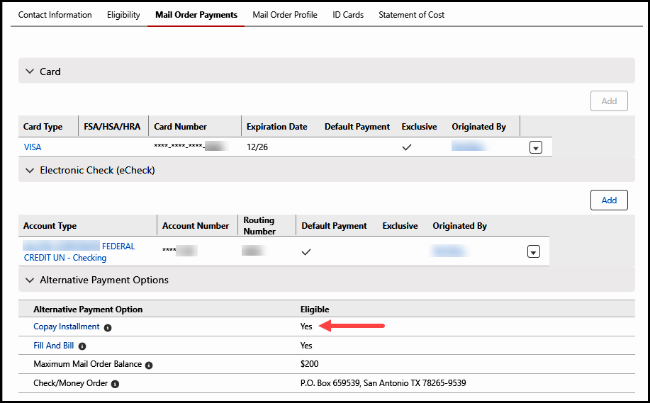

To review a transaction that was completed via copay installment payment, access the **Mail Order Payment History** screen from the Claims Landing Page select Current Balance hyperlink under Quick Actions panel. The payment will display as follows:

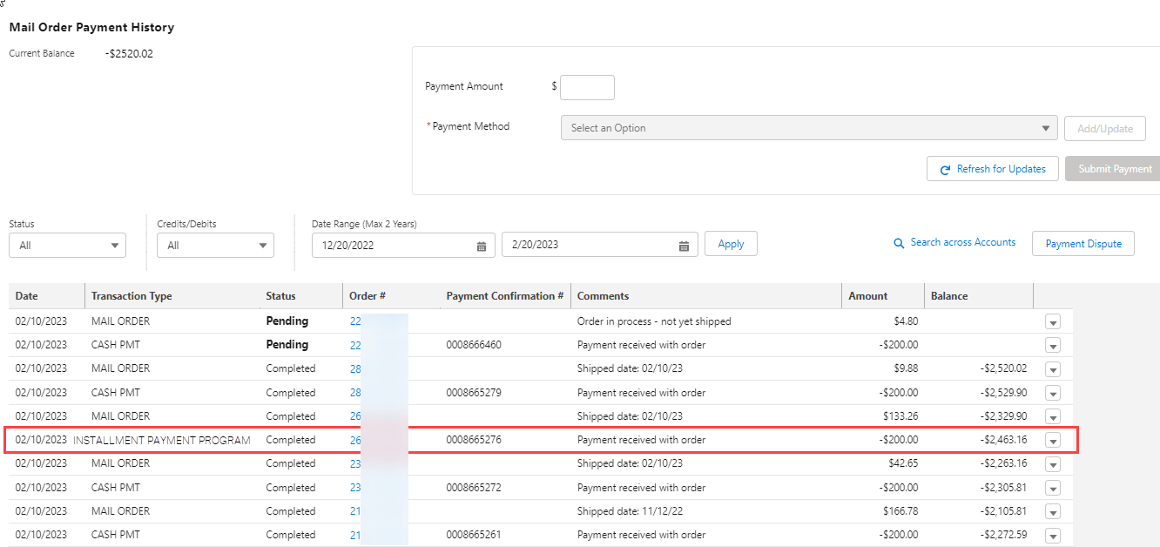

Top of the Document

|  |
| --- |
| Copay Installments on the Portal |

The Copay Installment Payments program will also be available on Caremark.com for clients who have opted into the program. Members can select this as a payment method when ordering prescriptions online by performing the following steps when checking out:

|  |  |
| --- | --- |
| **Step** | **Action** |
| **1** | Under **A New, Flexible Way to Pay**, click the **Set up Now** hyperlink.  **Result:** The “Pay for Prescriptions in # Installments” pop-up screen displays. |
| **2** | Follow the on-screen prompts.   * If the member’s default payment method is an FSA or HSA card, they will be instructed to choose a different account as their default payment method. Select the radio box adjacent to the proper payment method account to be charged and click **Change Default Payment Method**. |

Top of the Document

|  |
| --- |
| **Scenario Guide** |

Utilize the scenario guide for the following situations:

|  |  |
| --- | --- |
| **Scenario** | **Action** |
| Member’s default Payment Method is an FSA or HSA card | * A message will display stating that the default method of payment is an FSA/HSA card, which cannot be used for Copay Installment Program. Compass will disable the **Next** button. * The member will need to either:   1. Use an existing payment method that is not an FSA or HSA card, or   2. Add a new payment method that is not an FSA or HSA card and then set it as the default payment. Refer to [Compass - Add, Edit, and Delete Mail Order Payment Methods (Credit Card & eCheck) (056289)](https://thesource.cvshealth.com/nuxeo/thesource/#!/view?docid=5a1a67eb-a7b1-4ae5-bcfe-e986bbe4aa3d) as needed. |
| Member’s default Payment Method is marked as an Exclusive Payment Method | * Compass will prompt the agent to confirm they have spoken with the owner of the Exclusive Payment Method.      * + If agent selects the checkmark to indicate they have spoken to and authenticated the owner of the exclusive payment method, the **Place Order** button illuminates, and the agent will be able to complete the order.   + If agent has not spoken to and authenticated the owner of the card, or the caller wants to use alternative payment, click **Cancel** and select a different payment method. |

Top of the Document

|  |
| --- |
| Frequently Asked Questions |

Refer to the table below:

|  |  |
| --- | --- |
| **Question** | **Answer** |
| **What if the member changes their default payment method after the first of the three payments has been deducted? Which credit card will be charged for the remaining two payments?** | The remaining payments will be charged to the default payment method on file at the time the payments are charged. |
| **What happens if they have multiple Rx orders that occur on different dates?** | Separate orders will have separate series of installment payments. |
| **If I have multiple orders on an installment plan, can they be set up so that all are due on the same date of the month?** | No. |
| **What if the member requests installment payments for an order that has already shipped?** | Installment payments cannot be added to orders previously shipped without an installment payment plan attached. Installment payments must be added when the order is placed or before the order reaches **Ready Label** status. |
| **Will there be a Balance due if only one payment has been made?** | A balance due amount will not show on the member’s account unless one of the installment payments is declined. |
| **What occurs if a member has an outstanding balance due and then selects this payment method for a new order?** | Both amounts will be combined and split into three separate, equal installment payments.  **Example:** Balance due: $100, New Order Amount $200 = 100+200 = $300  Payment Amount Charged to Member will be: $100 in three separate payments |
| **Only specific clients have been approved for the installment payment program. How will we know which members will have this option to select on the portal?** | The portal option is driven by the client code. The installment copay option will only display for those members who have this benefit. |
| **If one order ships today and another ships 5 days from now. Will there be one series of installment payments?** | No, there will be two separate installment payment plans with six total transactions. |
| **How were clients chosen? Will we be offering installment copay to other clients in the future?** | These clients were chosen based on size and client desire for alternatives. This offering is currently limited but could be rolled out to other clients in the future. |
| **Will this place a HOLD on a member’s debit card for the entire amount or just each installment?** | The installments will be charged 30 days apart.  **Example:** For a 90-day refill placed on May 1st that costs $30, there will be a first charge on May 2nd for $10, then on June 2nd another $10 charge and then a final $10 charge on July 2nd. There will only be a hold for each installment payment when it is charged. |
| **What happens when a member doesn’t have the funds available for the 2nd/3rd copay?** | If an installment payment fails for any reason, the amount is returned to the account as a balance owed for collection. |
| **When selecting “Installment Payments” does that automatically go to the default card?** | Yes. |
| **How does a previous balance reflect if it is included in an order where the member has selected “installment” payments?** | **Example:** Member places a 90 refill that costs $20 and there is a previous balance of $10. The previous balance will be added to the current order amount, for a total of $30. Then the installment payment will divide the payments into 3 equal payments of $10. |
| **What if the copay is extremely high (Example: Over $600)? You could potentially have 3 installment payments of $200 each. Will that flag the “high copay” warning, divert the order and force a call to the member to approve the payment?** | The high co-pay divert would occur for the total order charge at the time the order is processed. The individual installment payments will not initiate an additional call(s) to the member. |

Top of the Document

|  |
| --- |
| Related Documents |

**Parent Document:** [CALL 0049 Customer Care Internal and External Call Handling](https://policy.corp.cvscaremark.com/pnp/faces/DocRenderer?documentId=CALL-0049)

[Customer Care Abbreviations, Definitions, and Terms Index (017428)](https://thesource.cvshealth.com/nuxeo/thesource/#!/view?docid=c1f1028b-e42c-4b4f-a4cf-cc0b42c91606)

Top of the Document

Not to Be Reproduced or Disclosed to Others without Prior Written Approval

**ELECTRONIC DATA = OFFICIAL VERSION - PAPER COPY - INFORMATIONAL ONLY**